Project Proposal

1. Introduction
This proposal outlines the architecture and implementation plan for developing a Common Data Environment (CDE) platform integrated with a Content Management System (CMS). The platform will provide a centralized environment for document management, collaboration, workflow approvals, and content publishing.
The proposed solution will utilize a modern cloud-based architecture designed for scalability, security, and high availability. The system will allow contractors, consultants, administrators, and reviewers to collaborate efficiently while maintaining strict document control and audit tracking.
The platform will be deployed on cloud infrastructure to ensure reliability, flexibility, and future scalability.

2. System Architecture Diagram
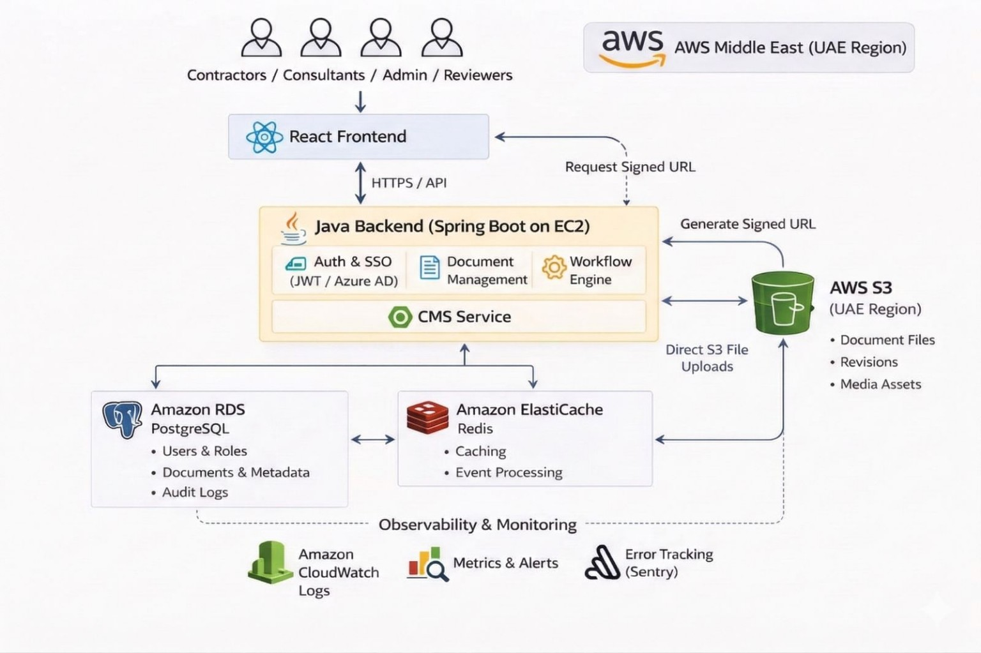

3. Technology Stack
Frontend - React, TypeScript, Tailwind CSS or Material UI
Backend – Java, Spring Boot, REST APIs
Database - PostgreSQL
Cloud Infrastructure
AWS EC2 – application servers
AWS RDS – managed database
AWS S3 – document storage
Redis – caching and event processing
Monitoring Tools
CloudWatch – system logs and monitoring
Sentry – application error tracking

4. Data Flow
The data flow within the platform will operate as follows:
- Users interact with the React frontend through a web browser.
- The frontend sends API requests to the backend application.
- The backend processes the request and applies business logic.
- The backend retrieves or updates data in the PostgreSQL database.
- For document uploads, the backend generates a signed upload URL.
- The frontend uploads files directly to object storage using the signed URL.
- Metadata related to documents is stored in the database.

5. Security Architecture
Security will be implemented across multiple layers of the system.
Authentication - The platform will use secure authentication mechanisms based on JWT tokens.
Authorization - Role-based access control will ensure that users only access resources permitted for their roles.
Secure Communication - All communication between frontend and backend services will occur through encrypted HTTPS connections.
Secure File Access - Files stored in cloud storage will be accessed through temporary signed URLs to prevent unauthorized access.
Audit Logging - All important user actions such as uploads, approvals, and edits will be logged for auditing purposes.

6. File Handling Strategy
The platform will support secure and scalable document uploads using a direct upload architecture.
Upload Process
- The frontend requests a signed upload URL from the backend.
- The backend generates a secure pre-signed URL.
- The frontend uploads the file directly to cloud storage using the signed URL.
Advantages
- Supports large file uploads
- Reduces load on backend servers
- Improves upload performance
- Ensures secure file access
Document versioning will also be supported to maintain revision history.

7. Scalability Strategy
The architecture will be designed to scale as the system grows.
Application servers can scale horizontally by adding additional instances.
Database services can scale vertically and support read replicas.
Object storage can support virtually unlimited file storage capacity.
Caching services will help reduce database load and improve response times.
The design ensures the system can support increasing numbers of users and documents.

8. Monitoring & Logging
System monitoring will ensure system health and performance visibility.
Infrastructure Monitoring
Cloud monitoring tools will track CPU usage, memory usage, and server health.
Application Logs
Application logs will capture API requests, system events, and operational logs.
Error Monitoring
Error monitoring tools will capture application exceptions and provide detailed debugging information.
Alerts can be configured to notify administrators when system issues occur.

9. Deployment Architecture
The platform will be deployed on cloud infrastructure.
Frontend Deployment - Frontend application can be hosted on a cloud hosting service optimized for static web applications.
Backend Deployment - Backend application will run on virtual servers in the cloud.
Database Deployment - Relational database will run on a managed cloud database service.
File Storage - Documents will be stored in a cloud-based object storage service.
This deployment architecture provides flexibility, reliability, and scalability.

10. Backup & Disaster Recovery
Data protection will be implemented through multiple mechanisms.
Database Backups - Automated backups will be enabled for the database to allow recovery in case of failures.
File Storage Protection - Object storage versioning will ensure that previous file versions can be restored if needed.
Disaster Recovery - Data replication and backup policies will help ensure data recovery in case of infrastructure failures.

11. Implementation Plan
The development process will follow a structured implementation plan.
Phase 1 – Architecture Setup
Cloud infrastructure configuration and development environment setup.
Phase 2 – Core Backend Development
Development of APIs, authentication, and document management services.
Phase 3 – Frontend Development
Development of user interface, dashboards, and CMS functionality.
Phase 4 – File Storage Integration
Implementation of document upload and versioning.
Phase 5 – Testing & Quality Assurance
Functional testing, performance testing, and security validation.
Phase 6 – Deployment
Deployment of the system to the production environment.

12. Timeline
Estimated project timeline:
Architecture & Setup – 2 weeks
Backend Development – 4 to 6 weeks
Frontend Development – 4 to 6 weeks
Integration & Testing – 2 weeks
Deployment – 1 week
Total Estimated Duration:
Approximately 12 to 16 weeks.

13. Maintenance & Support
After deployment, ongoing maintenance and support services can be provided.
Maintenance services may include:
System monitoring
Bug fixes and issue resolution
Security updates
Performance optimization
Feature enhancements

14. Cost Estimate
Development Cost
The development cost will cover system architecture design, backend development, frontend development, integration, testing, and deployment.
Estimated development effort may include:
- Architecture design and project setup – approximately 2 weeks
- Backend development – approximately 4 to 6 weeks
- Frontend development – approximately 4 to 6 weeks
- File storage and upload integration – approximately 1 to 2 weeks
- Workflow engine implementation – approximately 2 to 3 weeks
- Authentication and access control implementation – approximately 1 to 2 weeks
- Testing and quality assurance – approximately 2 weeks
- Deployment and configuration – approximately 1 week
Estimated total project duration: 12 to 16 weeks
Estimated development cost range:
- ₹5,00,000 – ₹7,00,000
This development cost will include:
- system architecture design
- backend API development
- React frontend development
- document upload and storage integration
- workflow engine implementation
- authentication and role management
- testing and deployment

Cloud Infrastructure Cost (Monthly)
The platform will be hosted on cloud infrastructure. The estimated monthly operational costs may include:
- Application server hosting (EC2): approximately ₹2,000 – ₹3,500 per month
- Managed database service (RDS): approximately ₹1,600 – ₹2,500 per month
- Object storage for documents (S3): approximately ₹400 – ₹1,600 per month
- Caching service (Redis): approximately ₹800 – ₹1,600 per month
- Monitoring and logging services: approximately ₹400 – ₹800 per month
Estimated total infrastructure cost:
- ₹5,000 – ₹10,000 per month
These costs may vary depending on:
- number of users
- document storage size
- system usage levels

Maintenance & Support Cost
Post-deployment maintenance and support services will help ensure system stability and continuous improvement.
Typical annual maintenance cost may range between:
- 15% – 20% of the development cost
Estimated annual maintenance cost:
- ₹1,20,000 – ₹2,00,000 per year
Maintenance services may include:
- bug fixes and issue resolution
- system monitoring
- performance optimization
- security updates
- minor feature improvements

Payment Milestones
The project can follow milestone-based payments structured as follows:
- 30% payment at project initiation
- 40% payment after development phase completion
- 30% payment after final delivery and deployment
This structure helps ensure transparency and aligns payments with project progress.

Cost Summary
The overall estimated costs for the proposed platform are as follows:
- Development cost: ₹5,00,000 – ₹7,00,000
- Monthly infrastructure cost: ₹5,000 – ₹10,000 per month
- Annual maintenance cost: ₹1,20,000 – ₹2,00,000 per year
These estimates provide a scalable and cost-effective approach for delivering the proposed CDE platform.

